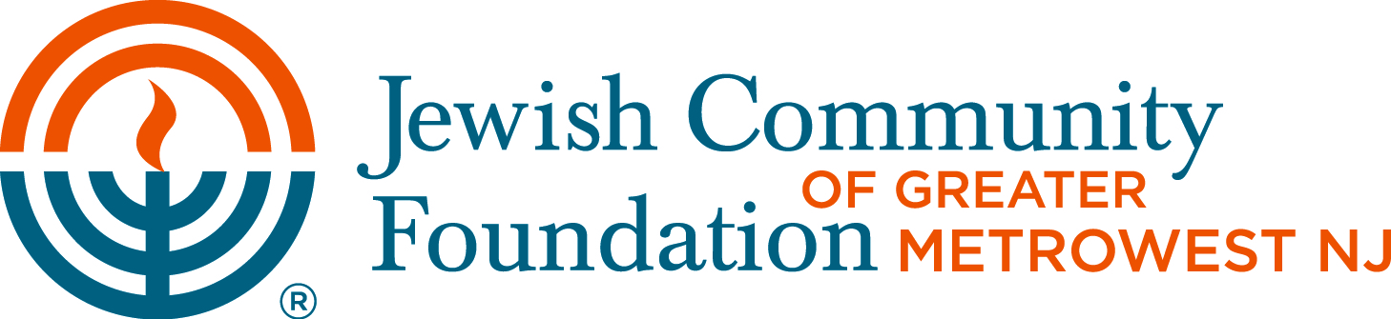

Managed Pool Asset Allocation Form

To: Jewish Community Foundation of Greater MetroWest NJ

Attention: Beverly Kestenbaum, Director of Donor Services

901 Route 10, Whippany, NJ 07981

Re: ___ _______________________
(Please Print Fund Name)

- I (We) recommend that the Foundation invest _ _____in the Managed Pool.
(NOTE: $250,000 minimum investment required)

- I (We) recommend that the Foundation invest the remaining assets as follows:

Fixed |  | Equity |  | Money Market |  | Total
 | + |  | + |  | = | 100%
(Choices)  25  50  75  100 |  | (Choices)  25  50  75  100 |  | (Choices)  25  50  75  100

Fund holders are limited to two investment allocation changes per fiscal year in the Equity, Fixed Income and ESG pools. Any fund holders interested in allocating fund assets to the Managed Pool must first review and sign the Managed Investment Pool Disclosure Statement and Informed Consent Form. Fixed Income investments may include alternative investments (e.g., hedge funds) that have shown risk reward characteristics of fixed income portfolios. Equities and ESG investments may include alternative investments that have shown risk reward characteristics of equity portfolios.

With respect to the Equities Pool, the minimum investment is $5,000. Fund holders are limited to two investment allocation changes per fiscal year in the Equity, Fixed Income and ESG pools.

Please submit this form via fax to 973-532-0781, US mail, or e-mail (from your personal email address to bkestenbaum@jfedgmw.org). Forms must be received by JCF by the 20th of the month in order to be implemented the 1st of the next month. Questions about this form and the JCF Pools should be directed to Serena Lee at 973-929-3094.

Name Signature Date

Name Signature Date

