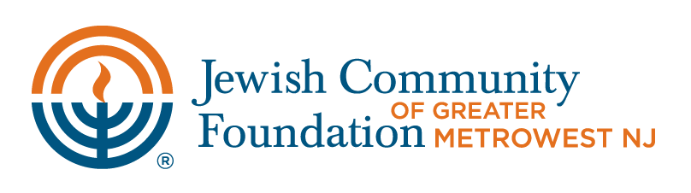

To: Jewish Community Foundation of Greater MetroWest NJ

Attention: Beverly Kestenbaum, Director of Donor Services
bkestenbaum@jfedgmw.org
901 Route 10
Whippany, NJ 07981

Re: __________________________________________ (“Fund”)
(Fund Name)

I (We) recommend that the Foundation invest the Fund as follows:

Fixed |  | Equity |  | Money Market |  | Total
 | + |  | + |  | = | 100%
(Choices)  25  50  75  100 |  | (Choices)  25  50  75  100 |  | (Choices)  25  50  75  100

Fixed Income investments may include alternative investments (e.g., hedge funds) that have shown
risk reward characteristics of fixed income portfolios. Equities and ESG investments may include alternative investments that have shown risk reward characteristics of equity portfolios.

With respect to the Equities Pool, the minimum investment is $5,000. Fund holders are limited to two investment allocation changes per fiscal year in the Equity, Fixed Income and ESG pools.

Forms must be received by the Foundation by the 20th of the month in order to be implemented the 1st of the next month. Please submit via fax (973)532-0781, mail, or e-mail. Fund holders are limited to two investment changes per fiscal year in the Equity, Fixed Income and ESG pools. If you have any questions regarding this form, please call Beverly Kestenbaum at (973)929-3063.

Signature Date

Signature Date

